Circuit Analysis
Laboratory Exercise No: 5
Transient Analysis for 1st-order RC Circuit
Introduction
The main objective of this laboratory exercise is to build, design, test and characterize 1st-order RC Circuits. In this lab, you will learn to observe the response of 1st-order RC circuit via the oscilloscope and to measure the time constant τ of the 1st-order circuit. You will learn to design a differentiator and an integrator.
Since many electronic devices and systems utilize pulse or rectangular waveforms, including computers, communication systems, and motor control circuits, we will study how RC circuits response to pulse waveforms. A pulse is a voltage or current that changes from one level to the other and back again. A pulse train is a repetitive stream of pulses. If a waveform’s high time equals its low time, it is called a square wave. The length of each cycle of a pulse train is termed its period, T, and the number of pulses per second is defined as its pulse repetition rate (PRR) or pulse repetition frequency (PRF) as shown in Fig.1.
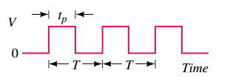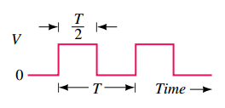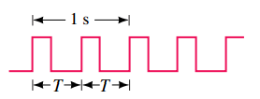
- Pulse strain (b) Square wave (c) PRR=2 pulses/s
Figure 1. Ideal pulses and pulse waveforms.
Part I
1. Pulse Response of 1st-order RC Circuit
In Fig.2, given R=5.1kΩ, C=0.22 μF, connect the circuit shown in Fig.2, using Function Waveform Generator as input and either v_{c} or v_{R} as output. Use Digital Oscilloscope to observe both the input and the output waveforms and measure the time constant.
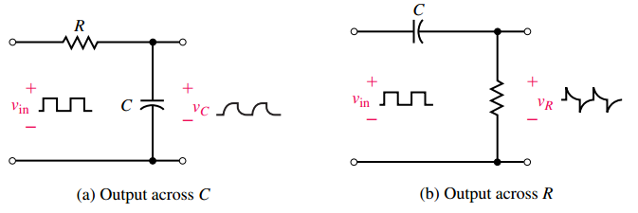
Figure 2: RC circuits with pulse input
2. Pre-Lab Work
a) Use circuit analysis techniques to solve the responses of v_{c} and v_{R} in the RC circuit shown in Fig.2. Understand the physical meaning of time constant. In order to observe the whole charging and discharging process clearly, you should design the value of PRF before you set it on the Function Waveform Generator.
b) Use Multisim as a help to proof your design by observing the simulating waveforms and then measure the time constant.
3. Lab Section 1
In this laboratory, you will learn how to build a RC circuit on a bread board, observe and measure the time constant. The procedure includes the following steps:
(i) Measure the resistance and capacitance rated R=5.1kΩ, C=0.22 μF,
(ii) Connect the circuit correctly,
(iii) Select Pulse Function from Function Waveform Generator, set the proper frequency and V_{p},
(iv) Adjust Digital Oscilloscope to show completely one or two both input and output waveforms,
(v) Measure time constant and compare it with theoretical value.
Part II
1. Design a 1st-order integrator
Use a given 1μF capacitor, a properly selected resistor and a LM324 Op-amp to build an active integral circuit. Use oscilloscope to observe the input and output waveforms, measure the maximum value of the input and output voltages and the frequency of the input square waveform.
2. Pre-Lab Work
a) Design an integral circuit. Analyze the circuit you have designed and solve the output v_{o}. Input a square waveform and draw the corresponding output waveform.
b) Use Multisim to simulate your circuit. Measure the maximum value of the input and output voltages and the frequency of the input. Compare them with the theoretical values.
3. Lab Section 2
In this laboratory, you will learn how to design an integral circuit on a bread board, to observe the input and output waveforms and measure the maximum value of the input and output voltages and the frequency of the input. The procedure includes the following steps:
(i) Measure the capacitance rated C=1 μF and the resistance of the resistor you designed,
(ii) Connect the circuit correctly (for the correct connection of LM324, see LAB 3),
(iii) Select Pulse Function from Function Waveform Generator, set the proper frequency and V_{p},
(iv) Adjust Digital Oscilloscope to show completely one or two both input and output waveforms,
(v) Measure the maximum value of the input and output voltages and the frequency of the input. Compare them with the theoretical values.
Part III
1. Design a 1st-order Differentiator
Use a given 0.47μF capacitor, a properly selected resistor and a LM324 Op-amp to build an active differential circuit. Use oscilloscope to observe the input and output waveforms, measure the maximum value of the input and output voltages.
2. Pre-Lab Work
a) Design an active differential circuit. Analyze the circuit and solve the output v_{o}. Input a triangle waveform and draw the corresponding output waveform.
b) Using Multisim to simulate your circuit. Measure the maximum value of the input and output voltages. Compare them with the theoretical values.
3. Lab Section 3
In this laboratory, you will learn how to design an active differential circuit on a bread board, to observe the input and output waveforms and measure the maximum value of the input and output voltages. The procedure includes the following steps:
(i) Measure the real capacitance rated C=0.47 μF and the resistance of the resistor you designed,
(ii) Connect the circuit correctly (for the correct connection of LM324, see LAB 3),
(iii) Select Triangle Function from Function Waveform Generator, set the proper frequency and V_{p},
(iv) Adjust Digital Oscilloscope to show completely one or two both input and output waveforms,
(v) Measure the maximum value of the input and output voltages. Compare them with the theoretical values.
5. Lab Report Submission
The report should include:
a) detailed Pre-lab works, including the circuit analysis, the solution of the outputs and their waveforms, the simulation circuits and their export waveforms,
b) calculations and measured data in a properly designed data table,
c) the output waveforms export from the Digital Oscilloscope.
You should submit your report to Moodle before 24:00pm 11th May for class 1 and 24:00pm 18th May for class 2.
Note: This is the last practical in this semester. The key word for this Lab is DESIGN. You are supposed to design the circuits, the parameters, the data tables and analysis and discussion questions. Do your best to make it an impressive report.

